**Running applicfation demo**

version 1.1

1. This is a login page where a user will enter his/Her user dtails and then the system will decide if the user name and password is correct, if the the user name is incorrect the system shows a message box that says incorrect username.

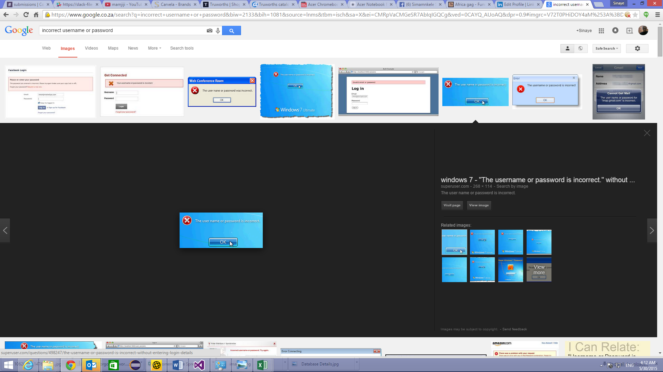

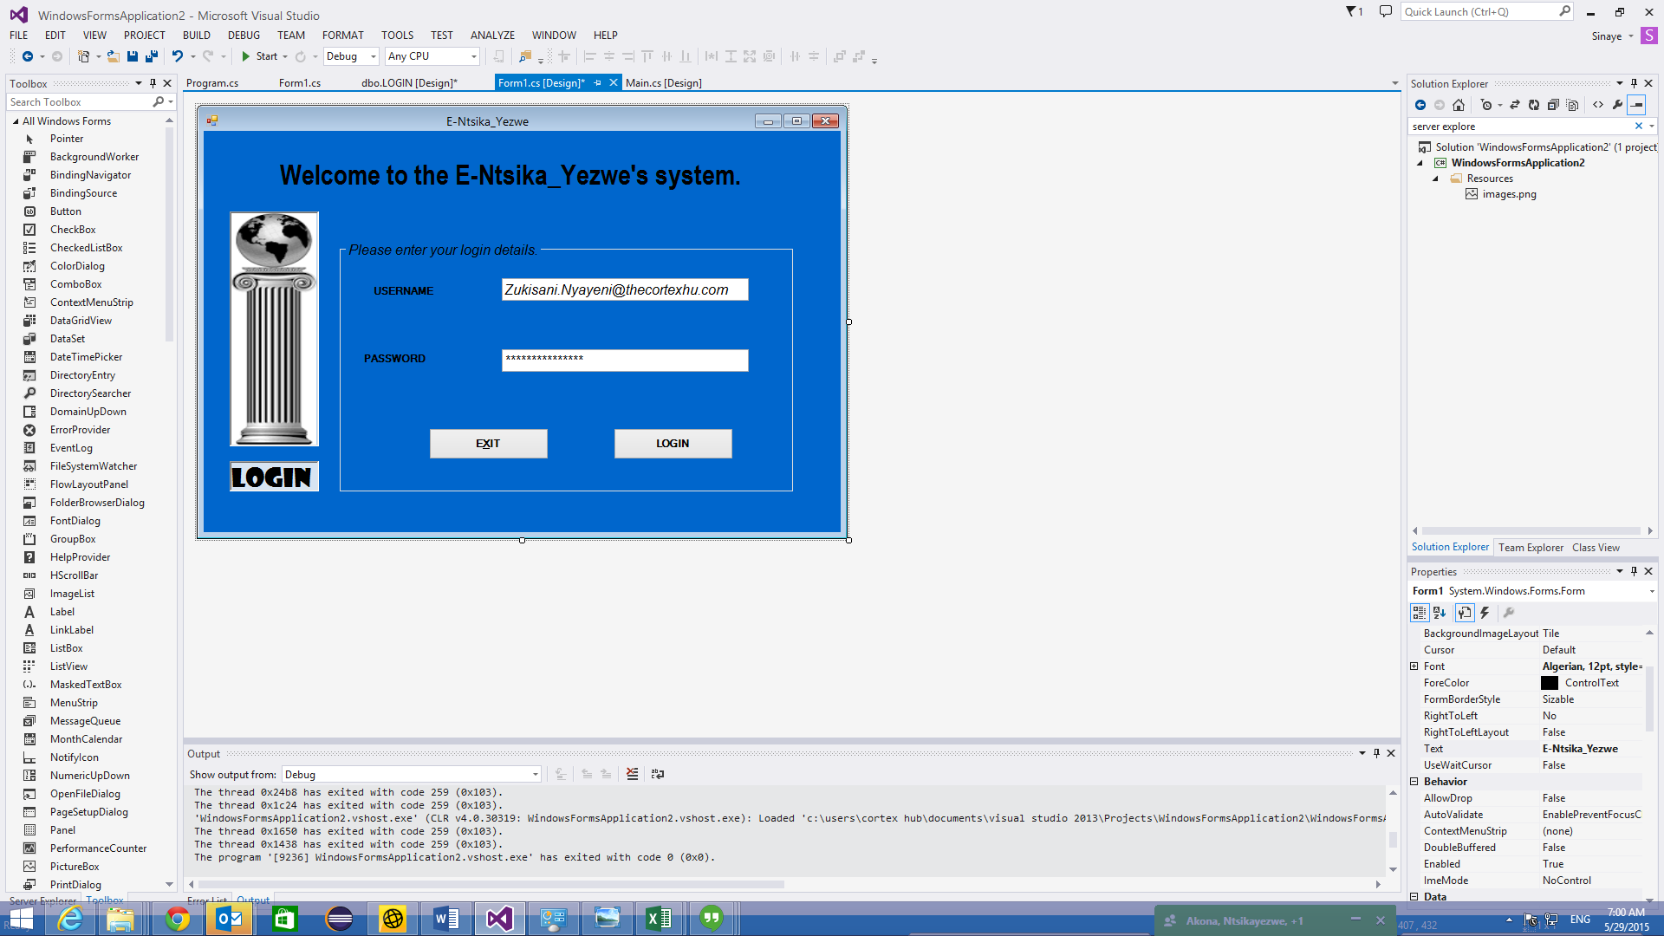

1. If the user name and the password is correct then the system will take you to this screen this is where the user will have to enter his/her information and submit. The information will be saved and the changes will be only be made the user.

